Test Connection

DB (mysql port 3306)

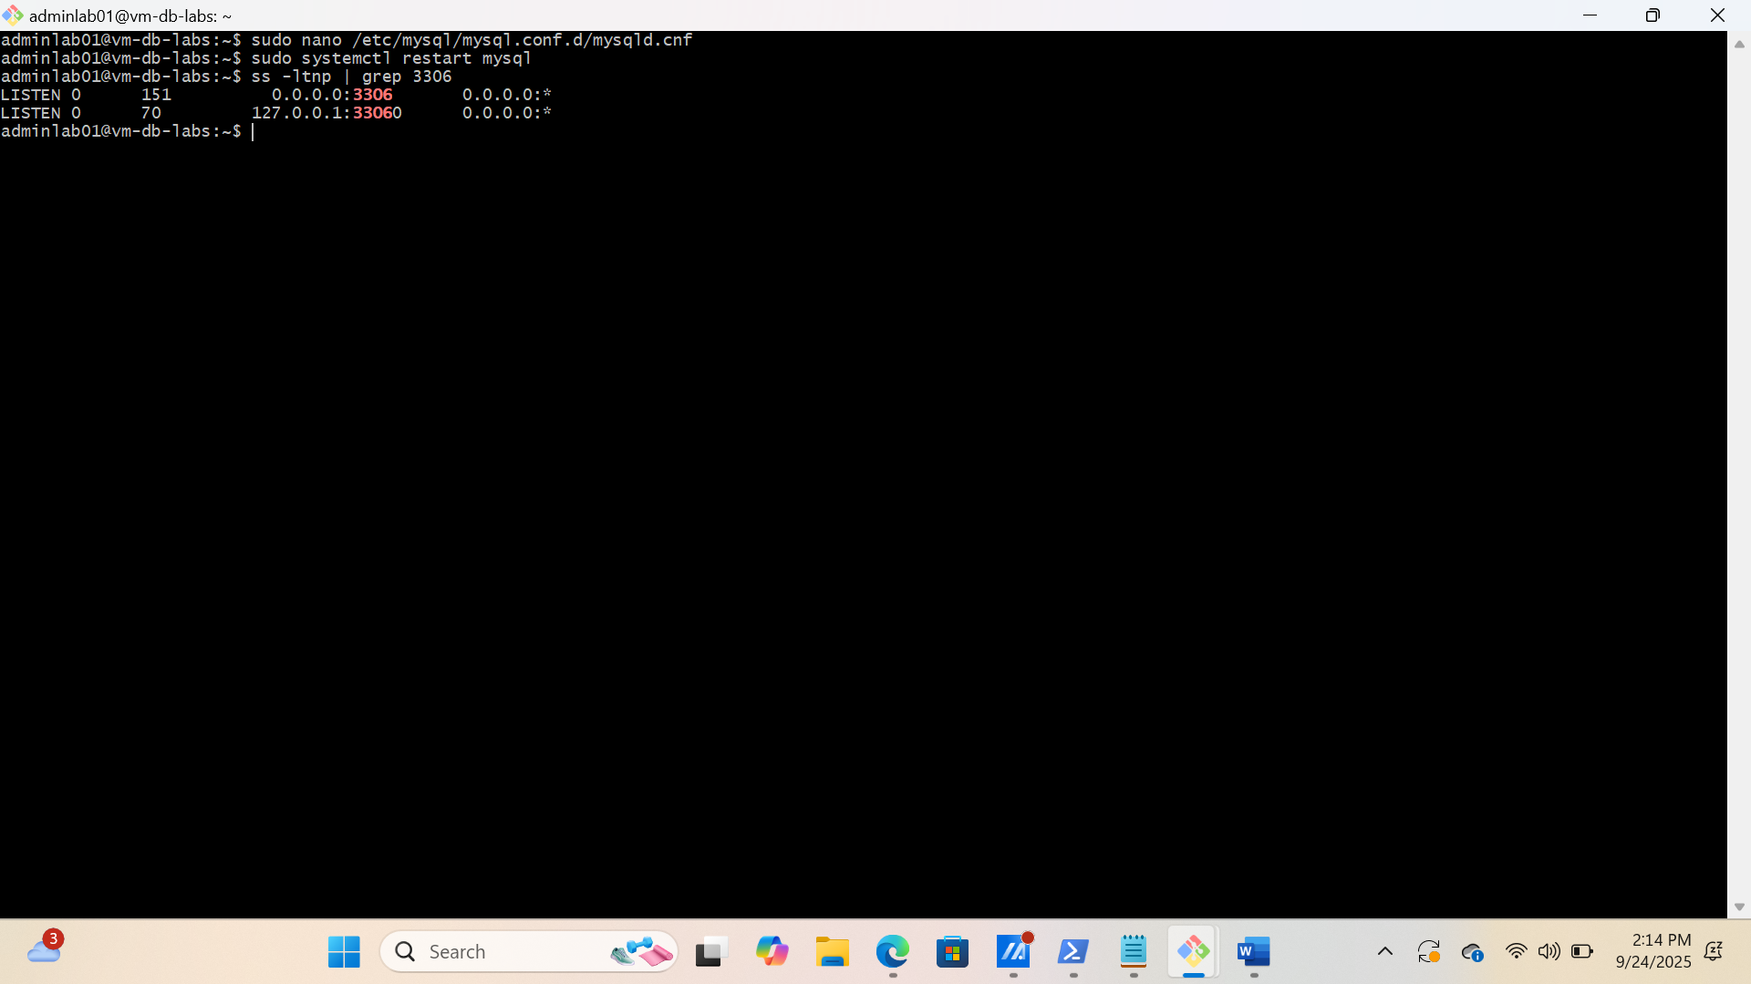

Web server

The screenshot shows that webserver can successfully access port 3306

